Semester 2 Final Review
Free Response Part 2

- Consider the following equilibrium:
$$2 {SO}_{2} \left(g\right)+ O_{2}\left(g\right)+197\frac{kJ}{mol}↔2{SO}_{3}(g)$$

  - The reaction is _______thermic and $∆H$ = _________
  - Which substances would have a heat of formation of zero? _____
  - Give the direction of the shift for each of the following:

    - Increase temperature
    - Increase [${SO}_{2}$]
    - Increase volume
    - Decrease [$O_{2}$]
    - Increase pressure

  - Write the K_{eq} expression for the equilibrium.
  - Calculate the value of the K_{eq} if at equilibrium
[${SO}_{2}$]=0.20 M, [$O_{2}$]=0.028 M, and [${SO}_{3}$]=0.56 M
K_{eq} =____________
- Sulfuric acid reacts with sodium hydroxide.
  - Give the balanced equation for this reaction.

  - If 20.00 mL of sodium hydroxide react with 40.00 mL of 0.050 M sulfuric acid, what is the concentration of sodium hydroxide?

= _______________
  - What mass of the salt is produced?

= _______________

  - What is the pH of the sulfuric acid?

= _______________

- A flask contains 672 mL of F₂O at STP.
  - Calculate the moles present.

= _______________
  - Calculate the mass present.

= _______________
  - Calculate the molecules present.

= _______________
- Name each of the following molecules.
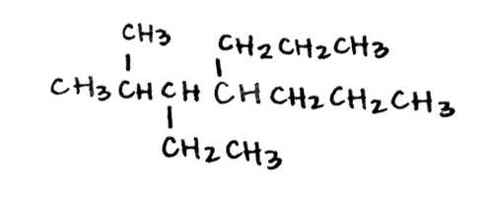 | 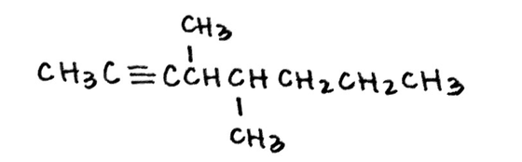
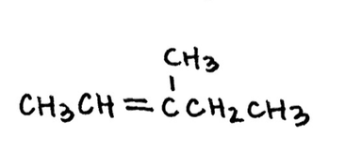 | 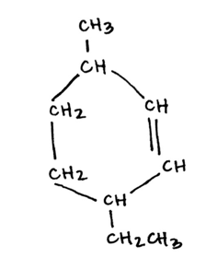

- Match each molecule with its functional group.
Functional Groups:
- Alcohol
- Aldehyde
- Amide
- Amine
- Carboxylic acid
- Ester
- Ether
- ketone
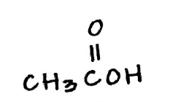 | 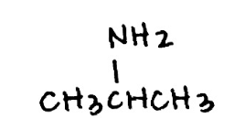
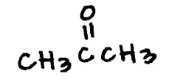 | 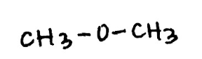
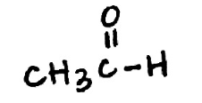 | 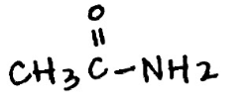
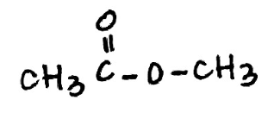 | 